CW1 Final.docx

CUonviveenrtstivty.'
ct I

Lo ndn0

Cover Sheet: Anonymous Marking
Student ID: xxxxxxx

Degree Title: Level:

Module Title: Module Code: Seminar Lecturer:

Assignment Title: Word Count:

Link:
To shared files, wordpress.com Blog, etc.
Global Business MBA 7

Corporate Social Responsib ility
M078LON
Sam Khan

CW1
3925

[Insert link here if relevant]

I, 8223393, confirm that this submission is my own work and I accept all responsibility for any copyr ight infringementthat may occur as a result of this submission.
Date of Submission: xxxx

- Executive Summary

Lottery business is in itself unethical because poor or middle-class people are encouraged to buy lotteries which creates a pool of money and some of it is given to the lottery winner.
Lottery can turn to gambling when people are determined to try their luck until they win.
National Lottery Franchise Camelot UK endorses at 'responsible playing' and 'changing
lives' both at the same time. This report is aimed at narrowing down all aspects of Corporate Social Responsib ility of Camelot Group and underlines the core areas that it needs strong focus upon in order to promote ethics and responsibi lity through its business.

CSR is a new trend in businesses around the world and very company reports or engages in society welfare and addresses issues like global climate change and welfare through their business. This report tries to underline that how much are they actually involvedand concerned with society and welfare with the help of critical analysis of CSR theories. There is a difference in behaviour of organisations in developed and developing countr ies and governing bodies like UNPRI lack the resources to take action on any negative event by the businesses to exploit people, society and the resources. With the help of six core principles of CSR we this report enlists how to integrate responsible behaviour in a business value chain and move towards Creating Sharing Value for a better future of the organisations, society and all the stakeholders involved.

In order to analyse the data from all angles I have used various resources such as textbooks , journal articles, biogs, arch ives of newspapers, classroom and seminar presentations, lottery industry publications, UK and National Lottery trends, company's financia l and annual reports and few case studies to reach the conclusion.

- C ontents
Cover Sheet: Anonymou s Marking ...
l. Executi ve Summary ...
- Contents
- Introduction ....

........ I
.....2
..... 3
..4

  - . What is CSR? 4
  - CSR in developed and developing countries 4
- Wh y Camelot Group ? 4
  - What Camelot Group does for CSR?. 5
- CSR St ra teg y: Came lo t . 5

5.1.
5.2.
5.3. 6. 6.1. 7.
7. I. 7.2. 7.3. 7.4.
Env iro nment .... Community ...... ..
Workplace .......
Stakeholders (Theo ry & Practice) : Camelot ..
Role of UNPRI
Core Characteristics of Corporate Social Responsibility .... ............. .... ...
Voluntary ......................
Managing-Externalitie
Multiple Stakeholder-Orientation ...... Socia l and Economic Alignment ..
...6
.. 7
..... 7
...7
... 8
............................ ... 8
..... 9
..... 9
............................9
. IO

7.5.
7.6.
8.
Practices and Valu es .... ........ .. ......... ..... ...... ....... .... ......... ...... ...... ..... ......... ...... ..... .......... . IO
Be yond Phil an thro py .... IO
Carroll's Pyramid of CSR . 11

  - . Econo mic Responsibilities 11
  - Legal Re s pons ibilitie s 11
  - Ethic al Respons ibilitie s 12
  - Phil anthro pic Re s pons ibilities 12
9. T hree-Domain Model of CSR 12
10 . Integrating CSR in Value Chain : CSV (Crea tin g Shared Value) | ....... .................. | .. 13
11. Future of CSR: Camelot Group .................................................. | ....... ...... ..... ........... | ... 14

- Conclusions 15
- Appendices 16
14 . References 18

- Introduction

  - What is CSR?
Corporate Social Responsibility (CSR) is a fast-growing area of interest for the society. The concept evolved mainly from USA because of the unregulated labour and capital markets with low levels of welfare and high individual freedom . (J.Moom, 2008) With increasing focus of media on organisations , especially after the global economic crisis in 2008, businesses are unde r pressure to justify their social respons ibility and increased need of apply ing and managing activ ities.

CSR can be defined as 'the firm's consideration of and response to the issues beyond the narrow economic, technical and legal requirement of the firm' (Davis, 2002)

  - CSR in developed and developing countries
CSR does not only differ from sector to sector but also quite substantially from country to country as well. (I.Hasnaoui & A.Freeman, 2011) Corporate commun ity contr ibutions by the compan ies of USA are ten times higher than the British companies (S.Brammer & S.Pavelin, 2005) However, in other parts of the world, like Europe, Asia and Africa social issues are addressed mainly by the collective actions or the government policies. However, globalisation has led to a boost of CSR activ ities, mainly because big multinationals are moving to developing countries for cheaper labour and raw materials. Developing countries not only have issues like corruption and domineering regimens but also low concern of human rights. With global companies entering their markets there is intense competition on small scale industries and domestic businessesto increaseprofits and match global
standards rather than investing in the social welfare issues. But on the flip side, many local businesses also recogn ize the importanceof CSR activ ities and sustainability it can bring to their business. (J.G.Frynas, 2005) My chosen company- Camelot Group operates in UK which is a developed country.

- Why Camelot Group?
Lottery business makes money out of people with financial trouble or sometimes general public by selling them the idea of 'getting rich quickly' or as UK's popular lottery business Camelot posts on its website 'Change Your Life' (R.V.Eyck , 2015)

Gambling and lotteries are more of an entertainment rather than a reasonable investment. But the actual reason of their existence is to create revenues for the state government. And it misleads by unethical ways of promoting and marketing the business to sell a chance to people to change their lives. (A.Kaminer, 2011)

The National Lottery is owned by the gambling commission and licensed to Camelot as a franchise agree ment to operate and it is one of the top revenue -generating sites in the UK. (Camelot Group, 2018) In last decade the National Lottery sales has increased by 40% due to innovation in game designs under the strategy of growth with CEO Andy Duncan since 2014.

Camelot in the UK reached ticket sales of £7.6 billion in 2016, from £7.3 billion in 2015. Profits before tax were £96.7m from £89.8m of previous year. (Financial Times, 2017). In 2017 , the ticket sale was 8.8% down at £6.92bn and as a part of strategic review a new CEO (Nigel Railton) has been appointed to turn things around in challeng ing situation for the company . With focus on returning to growth, improve its range of games, enhancing retail offerings and upgrading digital capab ilities. (iGaming Business, 2017) We can see the

values of Camelot Group (Fig.1) is to promote their ethical ways of doing lottery business, but this report will examine all aspects of Corporate Social Responsibility of Camelot Group.
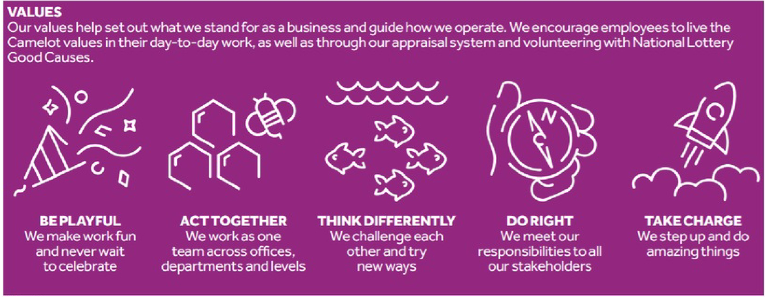
Fig.1

  - What Camelot Group does for CSR?
Total sales for Camelot for the year ending March 2017 were £6,925.3 million with contribution to charities of £1,628 million (Camelot Annual Report, 2017) Based on its numbers from financial report, here is a snapshot of its overall earnings and contribution to good causes. (Fig.2)
The report by the National Audit Office reported that profits for the company had shot up by 122% totalling £71 mn/year since 2010. But the amount offered to charities increased only by 2% with a fall of 15% last year April and it is expected to fall further this year.
(Guardian, 2017)
Apart from £36mn weekly contribution towards good causes Camelot engages in several voluntary employee engagement initiatives like chari ty, protecting green spaces etc. (Camelot Group, 2018)
Year in numbers 31-Mar-2017

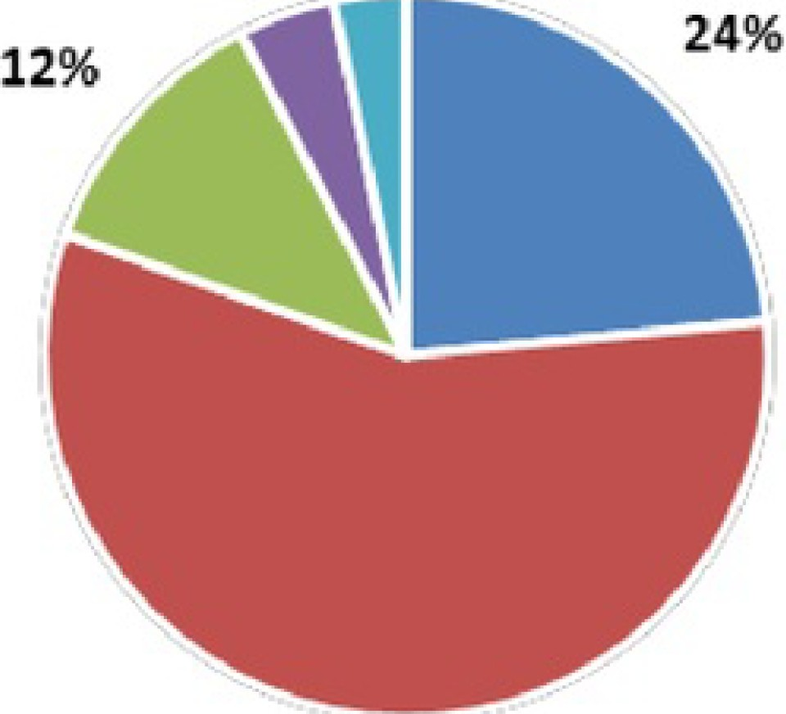
4% 3%
57%

    - Nat i onal Lottery Pr ojects • Player s • Government • Retailers CommiSsion • Other
Fig.2

- CSR Strategy: Camelot
Camelot 's current strategy claims to ' Promote Responsible Play' and ' Changing People's Lives' through their games and prize money. (Fig.3) Responsible gaming and lottery comes

to light with the innovation and mobile gaming aspect which requires more safety and security along with more responsibility on Camelot to monitor transactions. Its goal is to reach more and more people with variety of games (Fig.4) and lottery tickets to increase the sale. (Camelot Group, 2018)

Business Strategy: Corporate Responsible Strategy:

Building relationships

Broaden access with

Managing our world (responsible practices)

online platform

Building best In class
Life Changing

game portfolios
Maximise Participation eonsumer Protection (low average spending)

Fig . 3
.
r ei ic:!T:!il |  | r
Lotto | £2.00 per play | one £1 million prize and 20 winners of £20,000 every draw
EuroMillions | £2.50 per play | two UK millionaires everv draw - auaranteed.
Thunde rball | £1.00 per play | chance to win £500,000 not shared prize
Lotto H otpicks | £1.00 per Play I | Pick and match 3 Lotto numbers to win £800
Euro Millions Hotpic | £1.50 per play | Pick and match 3 EuroMillions numbers to win £1 500
GameStore | £1 - £10 per play | £50 - £4000000 prize money for variety of aames on mobile or on website

Fig.4

let us examine CSR strategies of Camelot with respect to Environment, Community &
Workplace

  - Environment

Sustainabili ty is the roadmap to the future which gives products and services a competency to evolve and gives direction to the organisation . It not only makes a positive business case but also helps organisations to take the lead in shaping the future with pollution prevention, clean technology and product stewar dship . (V.Shiva , 1991)

With respect to environment, Camelot is focussed on mainly four areas viz. Energy, Resources, Waste & Travel. Work ing with Camelot energy team they are taking initiatives to reduce the energy usage in their office buildings. Their customer facing resources like lottery tickets and scratch cards are recycled and new tickets are made from recycled paper . They also support and encourage use of bicycles and public transports for their employees with various promotional features such as bike parking facilities and shuttle bus services from stations to offices. Camelot has also achieved Carbon Trust Standard in 2014. (Camelot CSR Report , 2016) However, it has not done much to protect the underage play on its mobile and website applications.

5.2.Community

Donations and charitable initiatives were the first corporate CSR activities . (A.Carroll, 1999) Supporting communities for welfare, local contribution projects and encouraging independence initiatives like voluntary education or counselling in employee's free time have become popular in the recent years. However , straightforward monetary contribution to the communities is criticised for buying the local support as it has no real benefit to the firms. (D.Hess N.Rogovsky & T.Dunfee, 2002)

Camelot is involved in fundraising and volunteering activities that can help local communities with problems like youth unemployment through Prince's Trust , free helpline for old people called silver line, working across neglected green spaces for conservation projects with 40% of employees engaged in voluntary activities. (Camelot CSR Report, 2016)

During London Olympics £425m was reserved for constructing the Olympic Village from the Lottery Fund, but it was never constructed. Both Government and Camelot are answerable to charities. This makes us doubt weather this tax on poor people really goes to good causes. (Guardian, 2016)

5.3.Workplace
According to (D.Greening & D.Turban, 2000)Workplace is the starting point of CSR activities for an organisation in four ways:

- Corporate reputation and branding starts with employees
- It helps in attracting skilled workforce and build a competitive advantage of the organisation
- Organisations can implement CSR initiatives with employee engagement easily
- Employee welfare is the fundamental socioeconomic role of business

Camelot invests in its people in their learning and developmen,t health and wellbeing, encourages diversity and promotes employee engagement to keep employees happy and satisfied on job. (Camelot CSR Report, 2016)

However, Camelot has been criticised in the past for paying hefty bonuses to its top executives after increasing lottery ticket price from £1 to £2. It paid £6.5 mn to the top­ level executives which includes bonus for £900K and its chief executive Dianne Thompson was paid £1mn/year apart from her bonuses . (Daily Mail, 2014)

- Stakeholders (Theory & Practice): Camelot
Earlier the stakeholders were merely people who have stake or claim in the organisation, or who have direct relationship with company 's performance for economic interest. (M.Clarkson, 1995)
But now, key stakeholders are people or a group who can affect or contribute towards organisat ion's goals and objectives . Stakeholders act with three key attributes such as power, legitimacy and urgency with the organisations . (R. E. Freeman, 1984) Camelot's has wide range of stakeholders shown in (Fig.5) (Camelot Group UK, 2018).
Stakeholder theory with respect to Camelot suggests that all groups of people should be considered before making decisions and strategies. Camelot seems to be mainly focus majorly on its business growth irrespective of the impact of wide range of gambling and lottery business options on all ages and sections of the society. There is scope of further

improvement in its present CSR activities such as engaging in fund raising activities for the community or society, as well as promoting ethical business practices in the mobile gaming industry that has a huge potential to grow. (L.Wells, 2017)

  - Role of UNPRI
It is also the part of UNPRI and believes that responsible investments to grow their business comes from respecting the environment , considering labour and human rights which help the organisations in long term. UNPRI also focusses on Environmental, Social, Governance to enhance it through active ownership of organisations and reporting to reflect issues of welfare and human rights. (UNPRI, 2018)
However, UNPRI doesn't has a regulation mechanism in place to punish those who are guilty, in fact it provides a means to the organisations to bring their activities to light for marketing purposes . (J.Kew & J.Stredwick, 2015).

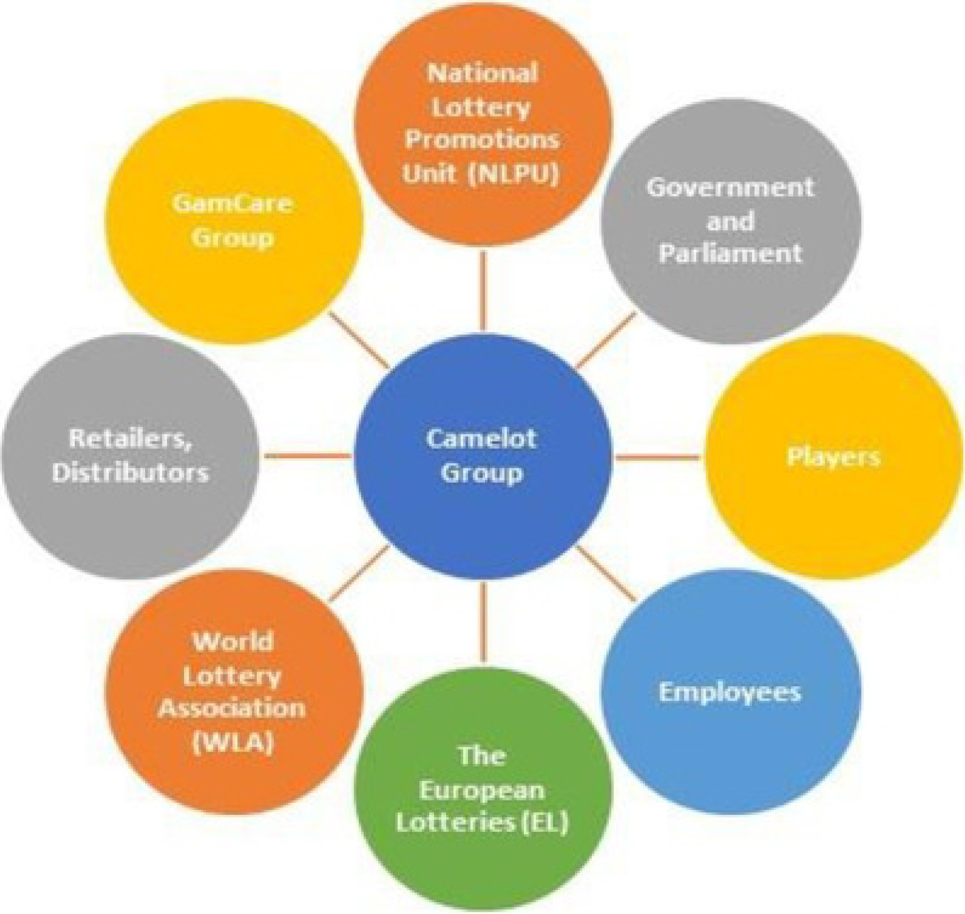 Fig.5
- Core Characteristics of Corporate Social Respons ibility

Earlier , the companies would generate profits and contribute to the society in a philanthropic way such as education or social investments or voluntary activities by employees to build a reputation or a brand in market for higher public acceptance. However, the recent changes in CSR demand proactive approach with responsible behaviour from the organisations . It focusses on making socially responsible decisions in their value chain like waste management, sustainable or renewable energy uses etc. (Fig .6) Let us examine 6 core characteristics with reference to Camelot in detail: (Fig.7)

Traditional CSR |  | Contemporary CSR
Focus | Risk | Reward
Drivers | Image, Brand, Public Acceptance | Performance , Marke ts, Products
Actors | Philanthropy, Corporation , | Corporation & Mul ti-stakeholder
 |  | networks
Relation to | No direct contribution , CSR is value | Integral goal, CSR is value
bottom line | distribution | generation
Orientation | Reactive | Proactive
Motto | CSR is 'bolt on' | CSR is 'built-in'
Fig.6

  - Voluntary
Corporate Social Responsibility is the illustration of all initiatives that are optional
and range outside the law. (D. Mele, 2008) In most of the developing countries this voluntary aspect is emphasised more. However, voluntary CSR is criticised for deviating the profit maximisation motive of business and organisation's core objectives (A.Hamidu H.Haronand A.Amran, 2015)

Employees get two days every year for voluntary activities that help in fund raising. Total 1468 hours were spent on voluntary activities with 1 in every 4 employee participants. (Camelot CSR Report, 2016) However, the fund-raising activities have not increased as much as its profits in the last decade. In fact, the organisation borrowed £75mn out of its fund reserved for good causes to improve the business and double the ticket price to £2 instead of£ 1. (Express News, 2014) Apart from that 40% employees are involved in trust or charity works like youth unemployment, care for elderly, conservation of green spaces etc. (Camelot CSR Report, 2015)

  - Manag ing-Externa lities
Any factors that are not part of the decision-making process of the organisation but are impacting the stakeholder's rights are externalities . Such as environmental issues that impacts the general public with the organisation's value chain or production. Most of the CSR activities deals with the externalities such as human rights , concern for environment and safety measures to reduce the health impacts of toxic or dangerous products. (B.Husted & D.Allen, 2006)

With increasing use of online and mobile games for lottery due to technological advancements , there is a increase in number of threats like safety and security of users data. As precaution millions of users were told to change their passwords after Camelot was hit by cyber-attack. (Evening Standard, 2018). Camelot is also proactive in providing support via email to players who show signs of unhealthy play or tools that report game addiction to encourage responsible play. (Camelot Group, 2018)

  - Multiple Stakeholder -Orientation
Stakeholder is any group or individual who can affect or is affected by the achievement of the organisational purpose. (Allison, 1971) This implies that organisation has CSR responsibilities towards their employees, suppliers, distributors and customers along with their shareholders. With the variation among industries and geographies at different levels. This opposes the traditional view of stakeholders which focussed on those who have put something at risk in relationship with the firm for the core economic interests (M.Clarkson, 1995). Even though shareholders are important stakeholders of any organisation but the success of the organisation depends on more people than just one. (A.Carroll, 1993)

Camelot has a wide range of stakeholders to address who have a direct impact on the way business and the actions it takes. (R.Peel, 2009) Stakeholders group comprises of players, winners, employees, public welfare and interest groups, government and local communities , dealers and distributors, shareholders and retaile rs. This can only be managed by the governance philosophy in each decision making with day to day operations reflecting the accountability. Like for example, preventing underage and addictive plays. (Camelot Stakeholders, 2018)

  - Socia l and Economic Alignment
This feature is focussed on progressive self-interest that is aligned with social and economic responsibilities. (A.Hamidu H.Haron and A.Amran, 2015) However, this creates a debate on implementing CSR activities are mainly for the business case on how firms can benefit from being socially and economically responsible. (A.Carroll & V.Edmondson, 1999)

Along with making huge wins through its games, Camelot also focusses primarily on maximising good causes that are socially-responsible and efficient like for example contributing into local communities , power sports teams and unleashing talent etc. (E .Smith, 2018)
Camelot has a cap on its operating expenses and therefore it is transparent to their expenses which shows responsible behaviour of management. (B.Martin, 2017)
However, the audit teams have reported that their contribution towards the good causes has not increased as much as their profits, which they are reinvesting to make their business bigger and better.

  - Practices and Values
Even though CSR aims to attend social and economic matters mainly, but organisational practices go beyond the business activities. Values of any organisation guide their practices and therefore hold importance to their overall activities . (W.Lei, 2011) This also raises disagreement and debates because what companies do with respect to values in the social aspect raises a controversy as they do this to realise some economic value out of it. Apart from organisation 's guiding values, the managers have a strong influence of their personal values towards their work too. (F.Duarte, 2010)

Camelot focuses on the mission to change lives with responsible playing. They are guided by values such as taking charge , acting together , thinking differently, being playful, doing right. (Camelot Group, 2018) Overall people are dissatisfied with the changes in gaming practices and trends in digital transformation , which cost nearly 25mn out of the good causes funds of the organisation (B.Martin, 2017) People feel tricked to buy lotteries with chances of winning games to be 1/45mn because of 10 extra balls added to the lottery ticket. Players were furious with this move which reflects in their sales figures dropping (Daily Mail, 2017) However, the current CEO N.Railton hopes that it will take some time to turn things around with respect to gaining people's trust. (Daily Star, 2017)

  - Beyond Philanthropy
CSR still has some philanthropic element to it in some regions of the world, where it is an obligatory practice towards the less fortunate . However, considering the impacts of CSR activities by the organisations it has become a strategic move. Today, CSR has become a mandatory practice in all aspects such as human resource , logistics , operations, marketing and all other core functions backed up by the regulations and international standards.
Therefore, it has clearly extended beyond philanthropy because of its strategic impacts on stakeholder expectations and proficiency to achieve organisational goals. However, there is a strong need for regulation and institutionalisation of the CSR practices rather than discretionary use for the business purposes. (D.Grayson & A.Hodges, 2004)

Being licensed under National Lottery, Camelot is supposed to be transparent on its spending and earnings. However, they had refused to release the information on spending of lottery cash in the past. (J.Ball, 2011) Recent changes in management and communication shows transparency and regulations . With every mention of sales of profits for Camelot, there is a mention of contribution for good causes which reportedly did not rise as much as its profits in the last 10 years. (K.Nelson,2018)

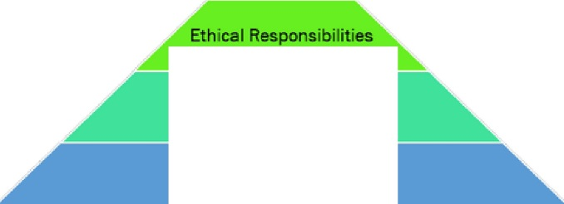

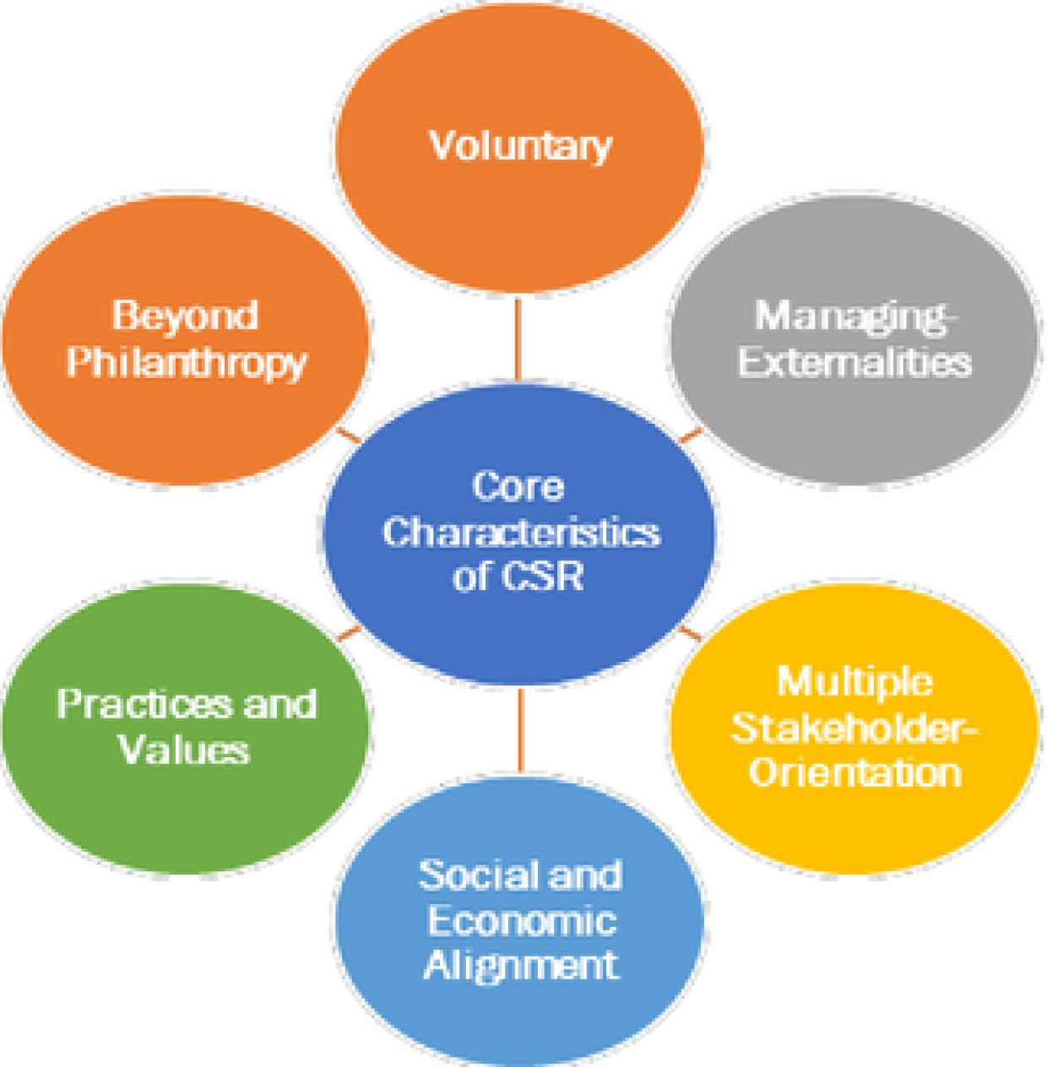
Fig.7

- Carroll's Pyramid of CSR
The debate on relationship between business and society has focussed the topic of CSR (R.Klonoski , 1991) To bridge the gap between economies and other expectations between ethics , legal responsibilities and optional anticipations that that society has from organisations. (A.Carroll, 1979) However , this model lacks the clarity on hierarchy of its domains and overlapp ing effects. (Reidenbach & Robin) Also there is a limitation on further development of these domains (M.Clarkson, 1995) (Fig.8)

Philanthropic Responsibilities

LegaI Responsibilities

Economic Reaponaibilitiea

--------------------Fig.8

Economic Responsibilities
Camelot claims to return 95% revenues towards the winners and the society, however the newspapers and audit reports show a different story. Even after steady growth in revenues for a decade and only marginal increase towards charity, followed by doubling the price of its lottery ticket from £1 to £2 in 2013 and recent changes in games that reduce the odds of winning jackpots for players, puts Camelot in a difficult position in its economic
respons ibilities. (Financial Times, 2017)

Legal Responsibilities
Gambling commission recently fined £3mn to Camelot for £2.5m prize ticket won by fraudulent way by a man who is a convicted rapist. (Guardian, 2016) There are millions of people who play with Camelot expecting the rules to win are fair, and both gambling commission and government and answerable to those people along with Camelot.

Nearly 26500 accounts of online players were hacked last year, for which gamers were asked to reset their passwords and investigationsare open. Camelot was also forced to close out its mobile applicat ion due to error issues with non-winning messages on scanning results . (iGaming Business, 2016)
There has been series of issues putting players and public interest at risk with incorrect results published on Lotto Raffle Games (iGaming Business, 2016) and breach in selling lottery tickets to under 16s by self-checkout machines in Aldi and Lidl stores and national lottery app which makes it easier to buy tickets for any age so that it can improve its sales numbers. (Financial Times, 2017)

  - Ethical Responsibilities
Camelot is licensed under National Lottery , which generates the revenue for the government to spend money on things that is generally covered with taxes. Like arts , heritage, sports and overhead cost of hospitals and schools. (N.Farndale , 2014) This looks like a tax on the poor people who try their luck at getting rich, putting them into soft drug of lottery which later develops towards hard drug of casinos and betting. Internet has made things uncontrollable and difficult to monitor for organisations like Camelot that aim at increasing their sales however are unaware of the consequences it can have on young kids in the age of digital world. It contributes12% to government taxes and 28% to charities and above all its 'nationallottery' apart from its existence and people buying tickets in a hope of instant gratification makes it least ethical from all aspec ts. (G. Giles, 1996)

  - Philanthropic Responsibilities
People living in the UK have strong trust on national institut ions and they believe that there are enough balances and checks in place for everyone's good. (Global Philanthropic, 2017) Camelot's direct return to the charitable causes declines by nearly 5% with £300m of losses in a decade. (H.Radojev, 2017)

- Three-Domain Model of CSR
The three-doma in model addresses the overlapping dimensions of Economic, Ethical and Legal aspects of business which were not addressed in Carroll's Pyramid Model of CSR theory. Instead of philanthropy as a separate domain, this model addresses it under the Ethical aspect. However , it presumes that all fields are distinctive and hence can be purely econom ic or ethical or legal.
Based on the discussion on core characteristics and Carroll's pyramid theory we can understand that Camelot is under Economic and Legal aspect of its business due to the nature of its business which requires people's money and trust of winning that they put into Camelot while buying their lottery tickets. It should address more of both ethical and legal responsibilities to protect its users and regain the faith of people in gaming purely for the entertainment purposes. (A. Gardner, 2016) (Fig.9)

Purely Ethical
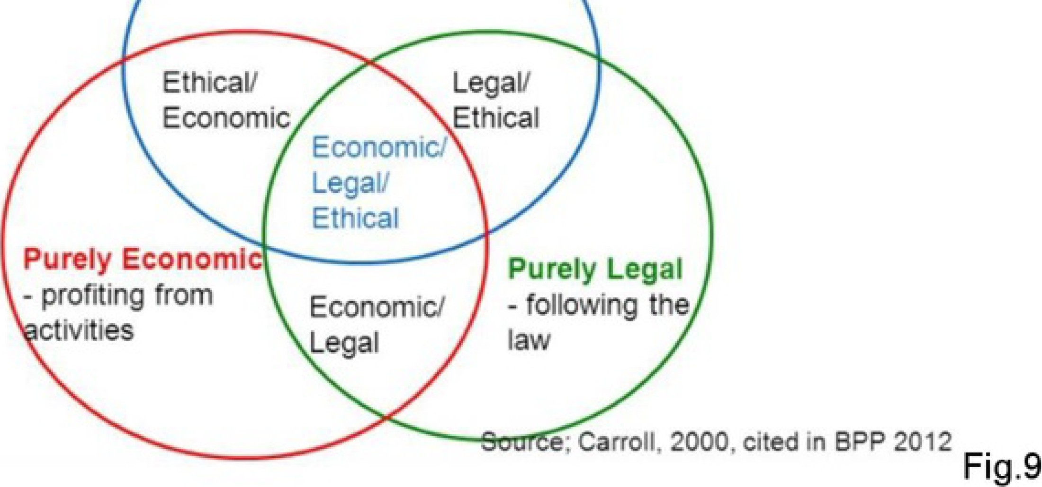

- Integrating CSR in Value Chain : CSV (Creating Shared Value)
One of the reasons why CSR is not as successful as it should be that it places Business against the Society, while in reality they are interdependent. CSR can be more than just a cost or charity or constraint for a business. It has the potential to lead the organ isation towards innovationand competitive advantage in many ways. (M.Porter and M.Kramer, 2006) It requires different thought process for organ isations to perceive respons ibility against society as an oppo rtunity rather than a damage control. For this (M.Porter and M.Kramer, 2006) suggest implementingCSR through value chain of the business and outline every single activity that integrate socially respons ible corporate behaviour. (Fig.10) This method has been popularly known as Creating Shared Value (CSV) which is more powerful approach than CSR as it is focussed on opportunities and not the costs to address social and environmental issues. (Guardian, 2013)

Camelot has keen focus on business growth, however integrating CSV model with their
J
value chain can help them become proactively engaged in CSR activities.
value chain can help them become proactively engaged in CSR activities.

University relations Lookln1 for ethical Pr'aCtiC:U
S:afety of products
Preserv;atlon of perishable materials Aecycllna

Flnanclal ,.eportlna p ctlc:es
Governance praetiees n-anspa,rency
use of lo bb vin
Profes$1onal trainina Worklni conditions Divenity and discriminations
Health ln$urance and other

r>ractlccs related to
purchasin1 p ctices
andchoosln& supplfers
Use of n111tu I
resou..-ces

..._,,-----' usofspecific
products

Impact on
transport

Emissions and waste Impact on biodiversity and

Impact on

Mar1Cet1na and advertlsfna
Prlc in1 s 1ra ·1e1v

Obsolete prod uct.s

ecolosv
tra nspo rt Information available lo
Consumer 1oods
I
L I policy

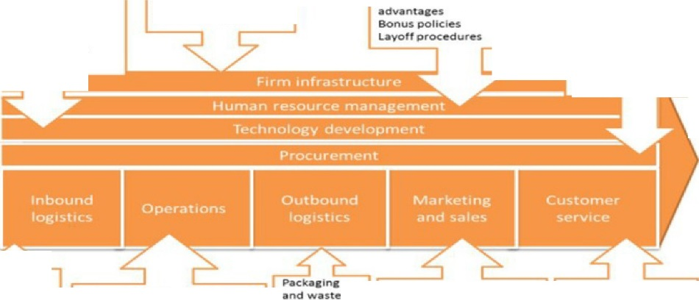

Fig.IO

Useof water and ener1v S,1,fetv ,111nd a,tmosphere In tne worl(place
Daneerous materials.
clients
Privacy poll,cy
:::aaemenl
prlv.acy

- Future of CSR: Camelot Group
Based on the analysis above we can say that currently Camelot operates under Reactive and Active ways towards its stakeholders. And transparency is the first step to drive change towards responsible behaviour. (Fig.11)

With proactive CSR approach, organisation engages with all internal and external stakeholders right from the beginning of its value chain or product life cycle. It should focus on 'inside -out and outside-in' approach in its practices and business methods. (R.Tulder with A.Zwart, 2006). Let us look at CSR Activities Camelot can address with Environment, Community and Workplace:

Environment
- Contribute towards clean technology by ensuring games are not addictive in nature.
- Ensure ethical games with players and disclose the list of applicants and winners for greater transparency.
- Protect Underage Play on Mobiles and Websites
- Use energy efficient devices in offices and promote more green ways such as recycling .
- Engage proactively in recycling paper and drive and promote plastic abandon ing.
- Engage with societies outside UK for promoting wellbeing and human rights in underdeveloped countries such as Africa and Asia.

Community
- Contribute towards pollution, waste management and renewable energy projects through good causes funds.
- Encourage voluntary services towards sports, arts, heritage, schools and hospitals along with monetary contributions
- Promote ecological diversity and conversion of endangered species and engage or act with NGOs on global warming.
- Set high standards of supply chain and engage them in community service activities .

Workplace
- More transparency of actions at all levels, more data and reports on good causes and welfare activities.
- Encourage employee trainings on counselling customers with gaming problems .
- More technical expertise to ensure data safety and security of online customers .
- Employee engagement to promote community service and social causes .
- Transparency in reports and data for protecting consumers and communities.
- Stakeholder meetings and reviews to be shared with their customers for transparency and building trust.
- Promote fair pay and labour rights, equality of income and women empowerment.
IN-ACTIVE | RE-ACTIVE | ACTIVE | PRO-ACTIVE
"Corporate Selj  Resoonsibilitv" | "Corporate Social  Resuo11sive11es s" | " Corporate Social  Resuo11sibilirv | " Corporate Socieral  Resoonsibilitv"
Legal compliance and ut ilita rian mot ives | Moral (negat ive) duty comp l iance | Choice for respon- sibil ity a nd vinue | Choice for in ter-active respons ibility
Efficiencv | Limit Ine fficiencv | Eaui tv/Ethics | Effectiveness
lndi fference | compliance | inte!l;rity | Disco urse ethics
Inside-in | Outside-in | Ins ide-out | In- outside -in/out
' doings things right " | " don ' t do things  wron2," | " doing the right th ings' | "doin g the right th ings ri!l;ht "
' doing well' | ' doin g well and doing good' | ' doing good' | ' doing well by doing good '

Fig.11

- Conclusions
Based on the research on global issues and their urgency, listed below are 10 opportunities for CSR that every organisation can benefit from. (M.Kaptein R.KoningV.Tulder and V.Vliet, 2007) (Fig.12) My research on Camelot shows that it needs to work a lot on its CSR activities as the business requires their attention to socially responsible behaviour in all aspects especially the environment and community where their major revenue comes from and should be directed towards to make the best effort to gain competitive advantage and potential growth oppo rtunities.

Lottery is played for fun and it is a source of entertainment for people. There is a fine line between lottery turning into Gambling where people are encouraged to try their luck to become rich faster. It is not only addict ive but has severe mental and social ill effects on people and the society especially for the kids. Technology is available to all and businesses should act responsibly towards the society when they encourage technology as a part of their business like mobile gaming. It can have severe consequences for underage players and their families and ultimately the society.

Camelot is funding public activities but is not transparent in its methods. There is a lot of negative publicity for its business practices and data governance. However , the best thing about social culture today is technology can spread the good as fast as it spreads the bad or negative news. Camelot has a lot to work upon and it can start by transparency and governance at all levels of gaming.

••••••••••
• • • • • ••
• *•*· •· :
• ... . •

- Appendices

- Camelot is the largest company in the world in Lottery Business.
Largest lottery companies worldwide
By lottery sales only (Sbn)

0
China Welfare Lonery (Chma) Chma Sports Lonery (China)
y Francaise 0,,. Jeux (France)

10 20 30 40

Camelot (UK) New York Lonery (US) Cal,forma Lonery (US) -
IGT (llaly )" ­
Caixa (Brazil-l
Sc1enttf,c Games (US)· •
Novomatrc LotterySolut1ons (Austna)" -
Tans Group (Ausrraha)" •
lntralot (Greece)" I
Pollard Banknote (Cananda)' j

' Torat revenue
SOurte Global Bemno ano Gamino Consultants
t FT

- Earnings of Camelot Group are close to £100Mn according to Financial Times.
Camelot's earnings
Pro fi ts be fore tax (£m)

100

BO

60
I I Ill 40

0
20
0

0
2004 07 09 11 13 1S 17
SOUfC@: Cal'Mlol
() FT

- Lottery and Gambling Addiction in the UK

'l"M report conl.MII IWIUJCI rei.ting tome g.ambllng TELEPHONE
industry111d,ci l(rigdom.Theinft;lrmd1011o:,nwn, -,
dacurnwll COWf'l bwnlh!J, bir9).. CUlnOl.atc.dn wpl,oM SUJWy1.
gamng fl'lldlinH. lom,ntt and pmblng -v.. ) l:Old"ing 4 OOOilftrwews

GAMBLING COMMISSION

45%otall
rHpOndents said that they had gambled In the past4weeks
27%haw pardcipall!cl
.. gambling educing
Nallonal Lottery Draws
18% haw pardcipall!cl 1n Nadanal Dmvsonly
Of these 1W4 year olds emerged as the least likely to gamble
33%
18·24 year olds are also most likely to be problem gamblers

And45-54
year olds 54%
emerged as the most likely to gamble

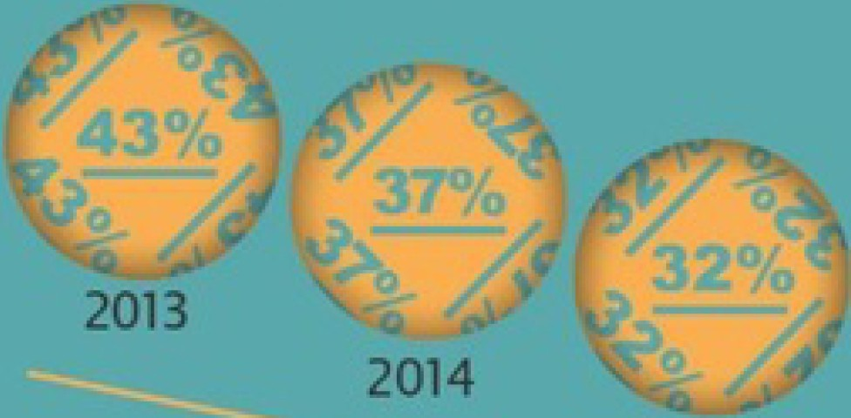
- Results from Gambling Commission on UK Gambling habits.
Participation In Nallonal Lottery Draws has
bee! decllnlng steadily
M.tptobltrn
"""""'"
15%
of all respondents gamb le
on line
""""'""
..
.
0.5%
.,
..
2015

·- ·

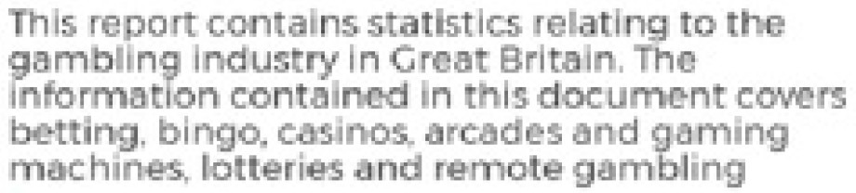
±±±±±±±±±± 48%
CAMB LINC PARTICIPATION
Data Is Cfrawo from four Quarterly telephone
surveys cond ucted du ring 2016 tota lling
4.000 Interview! Respondents are -'.'!lked &bout t lr ptist-four wttk g&mbllng part1dpahon

of people have gambled on

GAMBLING COMMISSION

Nat io na l lott ry draws are UM most popular activity.

.&..&..&..&..&..&..&..&..&..&.
1.1%
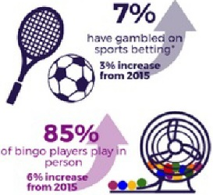
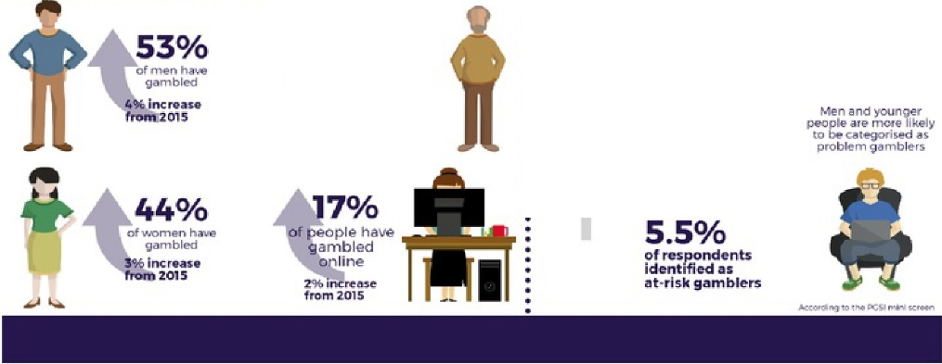
.L.L.L .L .L.L.L.L.L.L
.&..&..&..&..&..&..&..&..&..&.
±±±±±±±±±±
33%
have gambl<>d excluding
.I..I..I..I..I..I..I..I..I..I. .,.inc,w
- Pl.aying on mach ine-s
- i n a bookmalWfs ha$
- remained stab le
those who 1.5%
,L,L ,L ,L ,L ,L ,L ,L ,L ,L f,om'1015
: :r
......................................................
.L .L .L .L .L .L.L .L.L.&.
Lottery
draws

35-64
year olds
bre mo$t l1kel to have gambled, du en by
N a t io na l Lot tery pl 11y
:.' ...".""."P.«.• .d:l.'"V.t.t...iiu.,oJ.Ql.• .Ct., ......1./IQ.l"1.J.!t.o."h..lll.0 2.(1'4.0 .....'
0.7%
'•
; :m:_ d:s"u
problem gam bler s
l 'Mi in •
1ro n{ 201s
anyactivity
:z• dec r M
frorn201s
but pilrtidpiltion is doc:llnlng

14. References
(20 14). Retrieved from Daily Mail: http://www.dailymai l.co.uk/news/article-2265 725/National­
Lottery-operator-Camelot-5m-set-aside-s taff-bonuses .html
(2016 , August 6). Reh·ieved from Guardian: htt ps://,w vw.theguard ia n.co m/uk-
news/20 I 6/ a ug/06/c harities- dema nd-r etu m -o lym pics- lon don-20 I 2-lo tte1) 1 -cash
(20 I 7, ep te mber 23). Retrieved from Da il y Mail: http://v;ww .dai ly mail.co.uk/news/article - 4912566 /National-Lotte1y -w inners -hit-reduc ed-prize-draw.hhnl
(2018) . Retrieved from Camelot Group: htt p://www.ca melot group.co .uk/
A Gardner. (2016 , October) . Retrieved from
http s://3blme dia.com/sites/ww, ;v. 3blmedia .com/fi les/o ther /Best_Practice _028_Octo ber_2016_ FINAL.pdf
A.Carroll & V.Edmondson . (1 99 9). Giving Back To Society: An Examination of the Philanthropic 1'vlotivalions,Orienlati ons and Activities, Journal of Business Ethics, 19-2- 171 -9.
A.Carroll. (1979). Three Dimensional Canceptual Model o/ Co ,porate Pe,jormance , Acadamy Management Review, 497-505.
A.Carroll. (1993) . Business and socie ty: Ethics and stake holder management, 2nd Edition,.
A.Ca1rnll. (1999). Corporate Social responsibility - evo lution of a definition construct, business and society, 268-295.
A.Harnidu H.Haron and A.Arman. (2015 ). Corporate Social Responsibility: A Review on Definitions, Core Characteristics and Theoretical Persp ectives. Mediterranean Journal of Social
Sciences .
A.Kaminer. (20 11 , September 09). NY Times. Retrieved from
http ://www.ny tim es.com/20 11 /0 9/11 /magazine/t he-e thic ist -the-l os ing-tick et.htrnl A llison , G. ( 1971). Three Levels of O,ganisational Analysis.
B.H usted & D.Allen . (2006) . Co1porate social responsibility in the multinational enle1 prise: strategic and institution al approaches. Journal of International Business Studies , 37(6): 838-849 .
B.Martin . (201 7, October). Retrieved from Telegraph :
h ttps://w\vw.te legraph.co. uk/ finance/newsbysec to r/retailandcons umer /leisure/ 11 954005/Cam elot-bo ss-We-needed-a-bit-of-a-shake-up.html
Camelot Annual Report. (20 17, Ma rch). Reh·ie ved from
http ://www.came lo tgroup .co uk/assets/Uploads/ChainnanChiefExec201617.pdf
Camelot CSR Report. (2015 , Sep tember). Re trieved from
http://www.camelotg roup .co.uk/assets /Uploads/Camelot-CR-repor t-201 4-15- Final­ FINAL.pdf
CamelotCSR Report. (20 16 , M arch ). Retr ie ved from
http://www.camelotg roup.co.uk/assets/Uplo ads/Came lo t-CR-Report- 16-1 7-.pdf
CamelotGroup. (20 18 ). RelTieve d from http://www.came lo tgroup.co . uk/a ssets /Uplo ads/CP-S trate gy- 2018.pdf
Camelot Group. (2018) . Retrieved from http://v1ww.camelotg roup.c0 .uk/our -people
Camelot Group UK. (20 18 ). Retrieved from http://www.camelotgroup .co. uk/about-us/govemance
Camelot Stakeholders. (20 18 ) . Retrieved from http://www.camelo tgroup.co.uk/ about- us/governance/o w--stakeho lders
D. Mele . (2008) . Oxford University Press . C01p orate Social Responsibility Theories , In A. Crane el
al. The Oxford Handb ook of Corporate Social Responsibility, Oxford University Press . Retrieved from (2008) Corporate Social Responsibility Theories, In A Crane et al. (eds.) The Oxford Handbook of
D.G rayson & A.Hodges. (2004). Co1porale Social Responsibility: Seven steps lo 111ake CSR work for your business , Sheffield.
  - ree ni.ng & D.Tw-ban. (2000). Co,po rate socia l pe,fo rmance as a co111elilive advantge in altracting quality worliforce, Business & Society, 39-3 , 254 -280.
  - ess N.Rogovsh.')' & I. Dunfee. (2002). The next wave of co,porate community involvement, California1'vlanage menl Review.

Daily Star. (2017, November 22) . Retrieved from https://www.dail ys tar.eo.uk/news/latest­ news/661756/the-national-l otte1y -ca melot-C EO-nigel-railt on-slump -in-sa les-euromilli ons­ lotto
Davis , K. (1973). The case for and against business assumption of social responsibility, Acadamy of Managemen/J ournal, pp. 312-322.
E.Srnith. (2 018 ). Retrieved from https://peopleinsight.co.uk/case_studies/camelot/
Evening Standar d. (2018 , March 17 ). Retrieved from https://,w vw.standard.co.uk/fron t/national­ lotte1y -hacked-mi lli ons-told-to-chan ge-passwo rds-after-camelot- hit-b y-cy ber-attack­ a379237 I .htm l
Express News . (20 14, March 2). Retrieved from https://www.express.co.uk/news/uk/462729/Camelo t­ used-75million-of-charity-funds-as -it-doubled- ticket-price
F.Duarte . (2010). Working with Co,porat e Social Responsibility : The Role a/Manager's Values in the Maintenance of CSR Cullur es, Journal of Business Ethics , 355-369.
Financial Times. (20 17, April 27). RetTie ved from https ://w,;vw.ft.corn/content/e I c Id l 3b-c9ce-3d9a­ a lc 5-7a27da 668b28, by Nicholas Mega,v
Financial Times. (2017, November 12 ). Retrie ved from https://www.ft.com /conte nt/l 946797c-c4ac­ l le7- a ld2- 6786f39ef675 by Murad Ahmed
Financial Times. (20 17, November 21). Retrieved from https://www.ft.com/conten t/6efd8f54-ce I I­ I le7-b781-7 94ce08b24dc by Murad Ahmed,
G. Giles. (I 996). Retrieved from Philolsophy Now:
https://philosophynow .org/issues/14/Lo tteiy _or_Lootery
Global Phi lanlhropic.(2017, January 19). Retrie ved from
https://www.globalphilanth ropic.com/b log/2017/0 I /trust-philan thropy-data/
Guardian . (2 013, September 25). pp. https://www.th eguardian.com/susta inable-business/rnichael­ porter-co ined-competiti ve-ad van tage.
Guardian. (20 16, December 17). Retrieved from ht tps://www.theguard ian .com/uk-
news/20 16/dec/17/camelot-considers-opt ions-alleged-fraudu le nt-wi nner-rapi st-edward­ putnam by N.Slawson
Guardian. (20 17 , December 1 3). Retri eved from https://www.theguard ian .c om/uk-
news/2017 /dec/13/westrninster-watchdo g-investigates-came lots-funding-of-good-causes H.Radojev. (2017, November 21). Civil Society. Retrieved from
https://www.civils ociety.co.uk/news/returns- for-good-causes-from-national -lottery-fell-4-7- per-cent. html
I.Has nao ui & A.Freeman . (2011 ) . The meaning of c01p orale social responsibility the vision of four nalions, Journal of Business Elhics, pp. 419-443.
iGaming Business . (20 16, November 30) . Retrieved from
http://www.igarningbusiness.com/news/camelot-con firms-national-lo ttef)' -Online-acco unt ­ hacks
iGaming Business. (2016, July 28). Retrie ved from ht tp://www.ig arningbu s iness.com/news/camelot­ fined-300k-lotto-raffle-error
iGaming Business . (20 17, November 21). Retrieved from
http://www.igamingbusiness. corn/news/camelot-names-railton-pe1manent-ceo-reveals-hI- results
J.Ball. (2011 , October 3). Guardian . Retrieved from
https://www.theguardian .com/uk/20 l l/oct/03/camelot-national-lottery-money-distribution J.G.F1ynas. (200 5). The false developmenlal promise of c01p orale social responsibility: evidence from
mullinational oil companies, lnl em alional Ajjiars , pp. 81(3): 581-598.
J.Kew & J.Stredwick. (2015 ). Business Enviromnenl: Managing in a strategic context. Chartered Institute of Personnel and Development.
J.Moom , D. & . (2008) . l mplicit & Explicit CSR: a conceptual framework for a comparitive understanding of CSR. Acadamy of Management Review , pp. 33(2) 404-424.
K.Nelson. (20 I 8 , Janua1y 25). Daily Siar. Retrieved from https ://www.da ilysta r.eo.uk/news/ latest­ news/676743/National-Lotte ry-operator -Camelot-bosses -und er- fire -profits -soar-charitab le­ donat ions-fall

L.Wells. (201 7, November 27). pp. https://www.talkingretai l.com/news/industr y -new s/camelot­ outlines-plans-retum-national-lottery-growth-21-11-2017/.
M.Clarkson. (19 95). A stakeholderfiwneworkfor analysing and evaluating cOJporate social pe1for111ance. Acadamy of Management Review, 20: 92-11 7.
M.Kaptein R.KoningV.Tulder and V.Vliet. (2007). Report on European CSR.
M.Porter and M.Kramer. (2006, December) . pp. h ttps://hbr.or g/2006 /12/ trategy-and-society-the-link­ between-competitive-ad vantage-and-co rporate-social-re s ponsibi lity.
N.Famdale. (2014, November 15) . Telegraph . RetTieved from
https ://www.tele graph .co. uk/finance/personalfinance/I 1232956/Wha t-has-the -National­ Lottery-done-for-B ritain.htrnl
R. E. Freeman. (1984). Strategic Managemen t : A stakeholder app roach .
R.Klonoski . (I 991, July/August) . Foundational Considerations in the Co ,porate Social Responsibility Debate, Business Horizons , pp. 9-18.
R.Peel. (2009, October 16) . Retrieved from http://www.cs r360gpn .or g/magazine/ feature/came lots­ approach-to-stakeholder-engagement/
R.Tulder with A.Zwart. (2006). Int ernational Business-Societyivlanagement. London .
RV.Eyck. (2015 , April 14). Retrieved from
http://deredac tie.be/cm/vrtnieuws .eng lish/News/ l .2304319#
S.Bran1mer & S.Pavelin. (2005). Co,porate community contributions in the United Kingdom and the United States, Journal of Business Ethics, pp. 56, 15- 26.
UNPRI . ( 20 18 ). Retrieved from https:/Avww.unpri .or g/
V.S hi va. ( 199 1) . The terms of market economy, su,vival economy and nature's economy: Ecology and the policies of smvival, United Nations University Press .
W.Lei. (20 11). Perceptions of Corporate Social Responsibili ty Impl ementation : An Emphasis on Values.

CW1 Final.docx
GRADEMARK REPORT

FINAL GRADE

78

/100
GENERAL COMMENTS

Instructor

T hank you f or submitting the assignment.

Yous start to the executive summary needs working
on.

You have completed the assessment criteria on the module it shows clear direction on the organisation selected.

Good use of UNPRI

Your report is supported by theoretical f ramework and CSR models.

You needed to submit your report with 1.5 spacing. Good use of Carroll's Pyramid
T hree domain model needed f urther development. However, your attempt to apply other models within the report is excellent.

Good use of data and statistical inf ormation within the report.

Overall, good ef f ort.

PAGE 1

PAGE 2

PAGE 3

PAGE 4

PAGE 5

PAGE 6

PAGE 7

PAGE 8

PAGE 9

PAGE 10

PAGE 11

PAGE 12

PAGE 13

PAGE 14

PAGE 15

PAGE 16

PAGE 17

PAGE 18

PAGE 19

PAGE 20

RUBRIC: M0 78 CW2_1718

CRIT ERION 1 (5%)
Criterion 1 description. Executive Summary\nSetting of Context. (tobe no more than one\npage)
3.9 0 / 5

4 / 5

SCALE 1 NO SUBMISSION (0)

SCALE 2 POOR
(1)

SCALE 3 INCOMPLETE (2)

SCALE 4 BASIC
(3)

SCALE 5 APPROPRIATE (4)

SCALE 6 COMPETENT (5)

CRIT ERION 2 (5%)
No Executive<br />Summary or<br />Inadequate<br />inf ormation<br />provided.<br />

Very brief attempt at<br />an Executive<br />Summary. May be<br />more an Introduction<br />rather than a<br />summary. No<br />inclusion of <br
/>recommendations.<br />No in- text ref erencing<br />

Limited attempt at<br />providing an<br />Executive Summary.<br />Partial articulation of <br />the key f eatures of <br />the submission.<br />Limited inclusion of <br
/>recommendations.<br />Limited ref erencing.<br />Limited attempt to set<br />the submission in<br />context.<br />

An Executive<br />Summary is presented<br />which partially<br />highlights the key<br />f eatures of the<br />submission. Limited<br />inclusion of <br
/>recommendations but<br />with brief rationale.<br />Limited ref erencing.<br />Sets the submission<br />partially in context.<br />

Overall well- presented<br />Executive Summary<br />that articulates the key<br
/>f eatures of the<br />submission including<br />recommendations with<br
/>rationale. Overall good<br />ref erencing. Sets the<br />submission in context.<br />

Coherent well- <br />presented Executive<br />Summary that clearly<br />articulates the key<br />f eatures of the<br />submission including<br />recommendations with<br />rationale. Fully<br />ref erenced. Sets the<br />submission f irmly in<br
/>context of the overall<br />management report.<br />

4 / 5

Criterion 2 description. Introduction\nAbility to ef f ectively present the aim of the management brief . Giving a clear structure of the brief and arguments with\nan explicitidentif ication of areas\nof analysis and evaluation supported by relevant\nbackgroundinf ormation of the case study organisation

SCALE 1 NO SUBMISSION (0)

SCALE 2 POOR
(1)

SCALE 3 INCOMPLETE (2)
T he<br />management<br />brief lacks proper<br />introduction and<br />is poorly<br
/>structured. No<br />presentation of <br />the aims of the<br />brief . No<br
/>identif ication of <br />the relevant<br />arguments and<br />issues and no<br
/>background<br />inf ormation<br />provided.<br />

T he management<br />brief lacks proper<br />introduction and<br />presentation. It lacks<br />coherence and<br />provided very limited<br />presentation of aim(s)<br
/>of the management<br />brief . Equally giving<br />limited identif ication<br />of the relevant<br />arguments and<br />issues and some<br />background<br
/>inf ormation.<br />

T he management<br />brief lacks ef f ective<br />introduction and<br />presentation. T he<br />student provides a<br />report with a basic<br />structure and an<br
/>acceptable level of <br />coherency. Limited<br />presentation of the<br />aims of

the<br />management report.<br />Identif ication of <br />relevant arguments<br />and issues and some<br />background<br />inf ormation is given,<br />however which<br
/>require signif icant<br />level of development.<br />

SCALE 4 BASIC
(3)

SCALE 5 APPROPRIATE (4)

SCALE 6 COMPETENT (5)
T he management brief <br />has good introduction<br />and presentation. T he<br
/>student provides a<br />report with a prof icient<br />and coherent<br />structure. Good<br />presentation of the<br />aims of the<br />management report.<br
/>Identif ication of <br />relevant arguments<br />and issues supported<br />by relevant<br />background<br />inf ormation which<br />however requires<br />f urther development.<br />

T he management brief <br />has very good<br />introduction and<br />presentation.
T he<br />student demonstrates<br />the ability to produce a<br />report with a coherent<br />structure. Very good<br />presentation of the<br />aims of the<br
/>management report<br />supported with<br />relevant background<br />

T he management brief <br />has very ef f ective<br />presentation. T he<br />student provides a<br />report with a clear and<br />coherent structure.<br />T he
introduction<br />provides the aims of <br />the management<br />report and explicitly<br />identif ies the relevant<br />arguments and issues<br />to be address,
<br />supported with<br />relevant background.<br />T he identif ied areas<br />are developed logically<br />within the main body of <br />the analysis. T here is<br />a
f irm conclusion of <br />the areas discussed<br />that f ollow on f rom the analysis.<br
/>

CRIT ERION 3 (25%)
Criterion 3 description. Current CSR\nstrategy across national contexts Critical evaluation of the
4 / 5

organisation’s CSR strategy, clearly identif ying which valid theoretical models have application in dif f erent contexts in the assessment of the organisation’s current CSR strategy.T his must include the six core characteristics of CSR

SCALE 1 NO SUBMISSION (0)

SCALE 2 POOR
(1)

SCALE 3 INCOMPLETE (2)

SCALE 4 BASIC
(3)

SCALE 5 APPROPRIATE (4)
No evaluation of <br />data. No critical<br />investigation.<br />Models and<br
/>f rameworks<br />either not<br />considered or<br />poorly<br />represented.<br
/>Lack of <br />understanding of <br />the basic issues.<br />

T here is very limited<br />attempt at analysing<br />and evaluation of <br />data/ inf ormation.<br />Very limited<br />discussion of the<br />relevant models and<br
/>f rameworks. Limited<br />criticality presented.<br />Statements are very<br
/>descriptive.<br />

Demonstrates a very<br />limited attempt at<br />analysing and<br />evaluating<br
/>inf ormation/data.<br />Basic application of <br />the relevant models<br />and f rameworks. Very<br />basic and descriptive<br />in f orm.<br />

Demonstrates a limited<br />level of interpretation,<br />critical evaluation and<br
/>categorisation. T his<br />part of the submission<br />is generally descriptive<br
/>in f orm<br /><br />

Demonstrates the<br />ability to interpret,<br />critically evaluate and<br />categorise.
<br />Appropriate<br />f rameworks and<br />models are used f or<br />the analysis. A range<br />of implications f or the<br />organisation are<br />explored.<br />

SCALE 6 COMPETENT (5)

CRIT ERION 4 (10%)
Demonstrates the<br />ability to interpret,<br />critically evaluate and<br />categorise to an<br />exceptionally high<br />standard.<br />Interrelationships are<br />clearly developed and<br />illustrated. Implications<br />are f ully explored.<br />

4 / 5

Criterion 4 description. Recommendations - \nExamine how your\nchosen\norganisation’s CSR\nstrategy on the\necological\nenvironment can be\nf urther enhanced\nAbility to analyse and\nsynthesise\nunderstanding and\nknowledge of critical\naspects of the\norganisation’s CSR.\nArticulate such\nsynthesis in clear\nrecommendations. S

SCALE 1 NO SUBMISSION (0)

SCALE 2 POOR
(1)

SCALE 3 INCOMPLETE (2)

SCALE 4 BASIC
(3)

SCALE 5 APPROPRIATE (4)

SCALE 6 COMPETENT (5)

CRIT ERION 5 (10%)
T here is no<br />organisation of <br />ideas. Dif f icult to<br />f ollow logic. No<br
/>inf ormation<br />sources used.<br />Inadequate<br />inf ormation base.<br />

Unsubstantiated<br />recommendations<br />based on anecdotal<br />and generalisations.<br />Recommendations<br />not /poorly grounded<br />in reality. T here is no<br />linkage to preceding<br />material in the<br />assignment.<br />

Limited approach.<br />Recommendations<br />poorly developed with<br />limited theoretical and<br />practical evidence.<br />Issues of grounding<br />within reality. T here is<br />very limited or no<br />linkage to preceding<br />material in the<br
/>assignment.<br />

Good overall<br />approach.<br />Recommendations<br />generally coherent<br
/>supported by<br />theoretical and<br />practical evidence.<br
/>Recommendations<br />generally grounded in<br />reality. T here is limited<br
/>linkage to preceding<br />material in the<br />assignment.<br />

Very good approach,<br />partially analytical.<br />Recommendations<br />well def ined and<br />supported by<br />theoretical and<br />practical evidence.<br
/>Recommendations<br />grounded in reality.<br />T here is some linkage<br />to preceding material<br />stated in the<br />assignment.<br />

Analytical approach<br />with clearly and well<br />def ined<br />recommendations.<br
/>Coherent and<br />consistently supported<br />by theoretical concepts<br />and practical evidence.<br />Recommendations<br />grounded in reality.<br />Clearly links<br />recommendations to<br />preceding material<br />stated in the<br
/>assignment.<br />

4 / 5

Criterion 5 description. Recommendations Examine how your chosen\norganisation’s CSR strategy in the community can be f urther enhanced Ability to analyse and synthesise understanding and knowledge of critical aspects of the organisation’s CSR. Articulate such\nsynthesis in clear recommendations

SCALE 1 NO SUBMISSION (0)

SCALE 2 POOR
(1)
T here is no organisation of ideas. Dif f icult to f ollow logic. No inf ormation sources used.<br />Inadequate inf ormation base<br />

Unsubstantiated recommendations based on anecdotal and generalisations.
Recommendations not /poorly grounded in reality. T here is no linkage to preceding

material in the assignment.<br />

SCALE 3 INCOMPLETE (2)

SCALE 4 BASIC
(3)

SCALE 5 APPROPRIATE (4)

SCALE 6 COMPETENT (5)

CRIT ERION 6 (10%)
Limited approach. Recommendations poorly developed with limited theoretical and practical evidence.<br />Issues of grounding within reality. T here is very limited or no linkage to preceding material in the assignment.<br />

Good overall approach. Recommendations generally coherent supported by
theoretical and practical evidence. Recommendations generally grounded in reality. T here is limited linkage to preceding material in the assignment.<br />

Very good approach,partially analytical. Recommendations well def ined and supported by theoretical and practical evidence. Recommendations grounded in reality. T here is some linkage to preceding material stated in the assignment.

Analytical approach with clearly and well def ined recommendations. Coherent and consistently supported by theoretical concepts and practical evidence.
Recommendations grounded in reality.<br />Clearly links recommendations to preceding material stated in the assignment.<br />

3 / 5

Criterion 6 description. Recommendation - Examine how your chosen\norganisation’s CSR strategy in the workplace can be f urther enhanced Ability to analyse and synthesise understanding and knowledge of critical aspects of the organisation’s CSR strategy. Articulate such synthesis in clear\nrecommendations

SCALE 1 NO SUBMISSION (0)

SCALE 2 POOR
(1)

SCALE 3 INCOMPLETE (2)

SCALE 4 BASIC
(3)

SCALE 5 APPROPRIATE (4)

SCALE 6 COMPETENT (5)

CRIT ERION 7 (10%)
T here is no organisation of ideas. Dif f icult to f ollow logic. No inf ormation sources used.<br />Inadequate inf ormation base.<br />

Unsubstantiated recommendations based on anecdotal and generalisations.
Recommendations not /poorly grounded in reality. T here is no linkage to preceding material in the assignment. <br />

Limited approach. Recommendations poorly developed with limited theoretical and practical evidence.<br />Issues of grounding within reality. T here is very limited or no linkage to preceding material in the assignment.

Good overall approach.<br />Recommendations generally coherent supported by theoretical and practical evidence.by theoretical and practical evidence.
Recommendations generally grounded in reality. T here is limited linkage to preceding material in the assignment.

Very good approach, partially analytical.<br />Recommendations well def ined and supported by theoretical and practical evidence. Recommendations grounded in reality. T here is some linkage to preceding material stated in the assignment.<br />

Analytical approach with clearly and well def ined recommendations. Coherent and consistently supported by theoretical concepts and practical evidence.
Recommendations grounded in reality.<br />Clearly links recommendations to preceding material stated in the assignment.<br />

4 / 5

Criterion 7 description. Conclusions\nSynthesis of knowledge and understanding of f indings and various critical strategic issues f rom the CSR audit to draw and present coherent and consistent sets of CONCLUSIONS

SCALE 1 NO SUBMISSION (0)

SCALE 2 POOR
(1)

SCALE 3 INCOMPLETE (2)

SCALE 4 BASIC
(3)

SCALE 5 APPROPRIATE (4)

SCALE 6 COMPETENT (5)

CRIT ERION 8 (5%)
T here is no organisation of <br />ideas f rom f indings to a coherent conclusion<br />

T here is very limited organisation of ideas<br />and perspectives f rom f inding in the<br />analysis to draw coherent conclusion. Lacks logical presentation and very dif f icult to f ollow.

Demonstrates the ability to partially<br />organisation ideas and perspectives<br
/>f rom f inding in the analysis to draw coherent conclusion. Presenting limited support f rom analysis done.

Demonstrates the ability to organisation<br />ideas and perspectives f rom f inding in the analysis to draw coherent conclusion. T hough limited, but demonstrates some evidence of ability to logically synthesis f indings and critical issues in the business environment.<br />

Demonstrates the ability to organisation<br />ideas and perspectives f rom f inding in the analysis to draw very coherent set of conclusions that f ollow ef f ectively on analysis carried out. Easy to f ollow, logical presentation of synthesis of f indings and critical issues in the business environment.<br />

Demonstrates the ability to organisation<br />ideas and perspectives f rom f inding in the analysis to draw very coherent set of conclusions that f ollow ef f ectively on analysis carried out.<br />Demonstrates excellent ability to synthesise f indings and critical issues in the business environment and<br />logically presented<br /><br />

4 / 5

Criterion 8 description. Practical application of models, theories and f rameworks in the context of the case study company.

SCALE 1 NO SUBMISSION (0)

SCALE 2 POOR
(1)

SCALE 3 INCOMPLETE (2)

SCALE 4 BASIC
(3)

SCALE 5 APPROPRIATE (4)
No demonstration of practical application of the models, theories and f rameworks<br
/>to the organization<br />

T here is very limited demonstration of practical application of the models, theories and f rameworks to the organisation.

Demonstrates limited practical application of the relevant models, theories and f rameworks to the organisation.

Demonstrates a reasonable level of practical application of relevant models, theories and f rameworks to the organisation.

Demonstrates a very good level of practical application of relevant models, theories and f rameworks to the organisation.

SCALE 6 COMPETENT (5)

CRIT ERION 9 (10%)
Demonstrates an exceptional level of practical application of relevant models, theories and f rameworks to the organisation.

4 / 5

Criterion 9 description. Structure and Presentation\nDemonstrates a clear structure (required components covered clearly) with the points clearly presented and related together

SCALE 1 NO SUBMISSION (0)

SCALE 2 POOR
(1)

SCALE 3 INCOMPLETE (2)

SCALE 4 BASIC
(3)

SCALE 5 APPROPRIATE (4)

SCALE 6 COMPETENT (5)
Inadequate inf ormation base. T he submission is disorganised and incoherent. Does not f ollow the requirements as stated in the Assessment Brief

T he arguments are not properly related together and, to the extent they are, this is done in a manner that is weak, with no synthesis or analysis. T he assignment is
poorly organised with no proper balance between context, research, discussion, analysis and synthesis.<br />Does not f ollow the requirements as stated in the Assessment Brief <br />

T he relevant arguments are related together in a manner that is limited and does not achieve a reasonable synthesis. T he structure has a in equated balance between
context, research, discussion, analysis and synthesis. Partially f ollows the<br
/>requirements as stated in the<br />Assessment Brief

T he assignment is organised and the arguments are related together in a adequate manner, and there is some degree of analysis and synthesis but no originality.<br
/>Some problems with the f ormat and the level of prof essionalism.<br />Generally f ollows the requirements as stated<br />in the Assessment Brief .<br />

T he assignment is very well organised achieving a good balance between context, research, discussion, analysis and synthesis. T he structure clearly supports the
overall delivery of the author's argument. Follows the requirements as stated in the module guide.

T he assignment is outstandingly organised, achieving an excellent balance between context, research, discussion, analysis and synthesis. T he document is prof essional and ref lects the standards expected in academic or prof essional publications.
Follows<br />the requirements as stated in the module guide.<br />

CRIT ERION 10 (5%)
Criterion 10 description. Ref erencing Demonstrates range of appropriate academic literature with ref erences properly cited expressed in the CULC Harvard ref erencing f ormat
4 / 5

SCALE 1 NO SUBMISSION (0)

SCALE 2 POOR
(1)
No Attempt

Citing and ref erencing is very patchy, unclear and/or very inadequately placed in
context. T here is little mention of relevant literature, and any outline of these is highly restricted, unclear, and/or with no sense of context. In the f uture, better ref erencing and a stronger interaction with the question at hand would go f ar in helping to

achieve a pass.

SCALE 3 INCOMPLETE (2)

SCALE 4 BASIC
(3)

SCALE 5 APPROPRIATE (4)

SCALE 6 COMPETENT (5)
Some relevant literature is outlined, but this outline is patchy, unclear and/or not located in an adequate Harvard Ref erencing Format. Some major points of the
literature are brought out, but there are signif icant gaps, misunderstandings, and/or little grasp of detail or subtlety.

Citing and ref erencing is appropriate and there is a strong engagement with the literature. T he paper reads well, has strong transitions and carries a clear argument throughout, supported by accurate in- text citations and quotations in Harvard
Ref erencing Format

Citing and ref erencing is excellent and located in an appropriate context, there are no signif icant omissions and the essential points of the sources are brought out and related to reveal an excellent grasp of the topic in question combined with accurate in- text citations and quotations in Harvard Ref erencing Format

Extensive and relevant literature has been creatively chosen, properly cited,
ref erenced in Harvard Ref erencing Format, and outlined and located in an appropriate context.<br />T here are no signif icant omissions, and the essential points of the
sources are brought out and related to reveal an outstanding overall grasp of the topic in question, combined with accurate in- text citations and quotations.<br />

CRIT ERION 11 (5%)
Criterion 11 description. Clarity of expression (accuracy, spelling, grammar, punctuation)

4 / 5

SCALE 1 NO SUBMISSION (0)

SCALE 2 POOR
(1)

SCALE 3 INCOMPLETE (2)

SCALE 4 BASIC
(3)

SCALE 5 APPROPRIATE (4)

SCALE 6 COMPETENT (5)
Signif icant problems with structure and accuracy in expression. Very dif f icult to f ollow and understand.

T he overall and specif ic meaning of the writing is unclear. T here are consistent grammatical and spelling errors throughout the submission.

T he overall meaning can generally be understood. However the quality of the writing is variable.<br />T here are consistent errors in spelling, grammar and punctuation.<br
/>

Writing style generally f luent. Spelling, grammar and punctuation generally accurate.

Fluent writing style. Spelling, grammar and punctuation accurate.

Exceptionally f luent writing style. Engaging to read. Spelling, grammar and punctuation accurate.

